

24CSCI03P

Principles of Web Programming

Pengar

# Phase 1 Report

## Group # (52)

### **Members:**

|  |  |  |
| --- | --- | --- |
| ID | Student Name | BUE Email |
| 253561 | Abdullah Mohamed | abdullah253561@bue.edu.eg |
| 260727 | Eyad Marii | eyad260727@bue.edu.eg |
| 258638 | Abdelrahman Ahmed | abdelrahman258638@bue.edu.eg |
| 258885 | Ahmed Hisham | ahmed258885@bue.edu.eg |
| 250706 | Ahmed Mossad | ahmed250706@bue.edu.eg |
| 251296 | Rashed Mohamed | rashed251296@bue.edu.eg |

Topic approval & Planning analysis sheet  
  
Deliverables:

* Project title, student names, ID’s and emails.
* In the table above, Title; Pengar.
* What is the purpose/ goal of this website?
* To provide a comprehensive and all-inclusive platform for both individuals and institutions to invest and trade while being well informed of the state of the financial world through our news network.
* Who is your audience?
* Individual people as well as corporations.
* What opportunity, problem or issue does the site address?
* There isn’t a platform that combines all the aspects of Trading, investing, expert insight and news delivery into one accessible and easy to use platform.
* What type of information/content might be included?
* Relevant and up to date information in the trading world aligning with our efforts to deliver professional insight. We would also deliver the latest events in our fund and future plans for growth. Lastly, we would provide supplementary news content so that our users have the latest and greatest information to be able to navigate the market.
* List at least 2 related websites and why you chose them
* [Robinhood: 24/5 Commission-Free Stock Trading & Investing](https://robinhood.com/us/en/)
* [BBC Home - Breaking News, World News, US News, Sports, Business, Innovation, Climate, Culture, Travel, Video & Audio](https://www.bbc.com/)
* [The fund's value | Norges Bank Investment Management](https://www.nbim.no/en/investments/the-funds-value/)
* These websites provide some aspects of our core services, yet lack the combined experience that we plan to deliver.
* How will your project use a form?
* Sign in
* Contact form
* Careers (Job openings)

Wireframes:

HOME

(world map)

Markets

News(business)

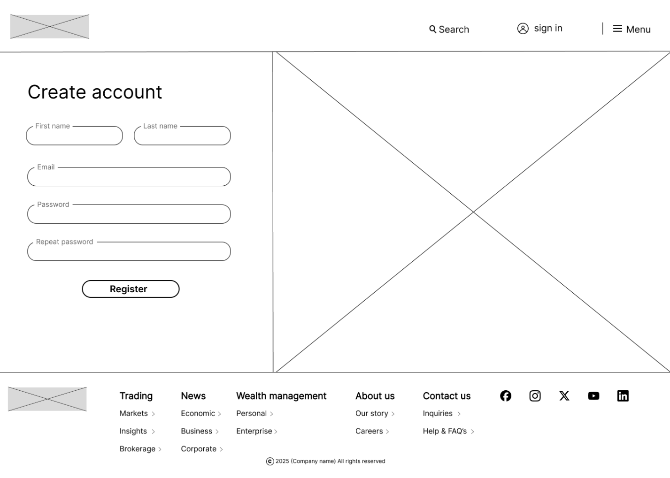

Sign in

Menu

Validator:

Tables:

|  |  |
| --- | --- |
| Currency($) | Converted(£) |
| 10 | 13 |
| 13 | 16 |

|  |  |
| --- | --- |
| Crypto(1) | USD($) |
| bitcoin | 42500 |
| 2 | 3200 |

|  |  |
| --- | --- |
| stock | USD($) |
| Apple (AAPL) | 175 |
| Tesla (TSLA) | 210 |
| Samsung (SSNLF) | 998 |